5. Rudder / Trim Tab

5.3 Trim Tab Stuffing Box Removal and Overhaul

In the summer of 2005 during a routine check of the bilge area I discovered a small but consistent leak emanating from the trim tab post just below the stuffing box nuts. The cause was a crack in the trim tab stuffing box tube just below the stuffing box packing nut assembly. I temporarily wrapped a rubber tire inner tube and hose clamped the rubber tightly around the trim tab post to stop the leak.

The following is a documentation of the repair made to the cracked trim tab tubing. The repair was performed during the winter and spring of 2006, with the boat out of the water.
Special thanks to Lars Strom, the technical director of Nautor, for all his guidance and also providing the technical drawing of the trim tab tube assembly.

In order to gain access to the trim tab tube and stuffing box packing nut assembly the following items required removal.

- Trim tab quadrant (see figure 1, 2).
- Trim tab stock upper bushing and aluminum brace plate (see figure 3).
- Fiberglass battery box located immediately aft of the trim tab quadrant just forward of the engine box – below the cabin sole. This is necessary in order to remove the aluminum brace plate (see figure 4).

Once the trim tab tubing and stuffing box packing nut became accessible the source of the water leak was obvious. There was a crack and missing metal at the top portion of the trim tab tubing due to corrosion. The crack and missing metal was primarily isolated to the area of the threaded portion of the tubing used for adjusting the packing nut (see figure 6). After removing the second bushing set into the top of the trim tab tubing proceed to cut down the trim tab tubing using a small metal cutting disc on a Dremel hand tool (being careful not to cut into the trim tab stock). In my case 1.5 inches of the existing tubing was cut off. Re-fit the previously removed bushing into the top of the newly cut down trim tab tubing (note: the outside diameter of the existing bushing will need to be turned down slightly on a lathe to seat into the cut down trim tab tubing). Install a new stuffing box / packing nut assembly (such as a standard bronze Edson stuffing box / packing nut unit) and slip this assembly over the remaining trim tab tubing. Secure the new stuffing box / packing nut assembly using double stainless steel hose clamps. Make sure to purchase quality stainless steel hose clamps. (not cheap units made in China) and test them before installing with a magnet to ensure both the band and the threaded portions are indeed stainless steel.

Once the new stuffing box / packing nut assembly installation is completed the installation of items previously removed is the reverse of disassembly.

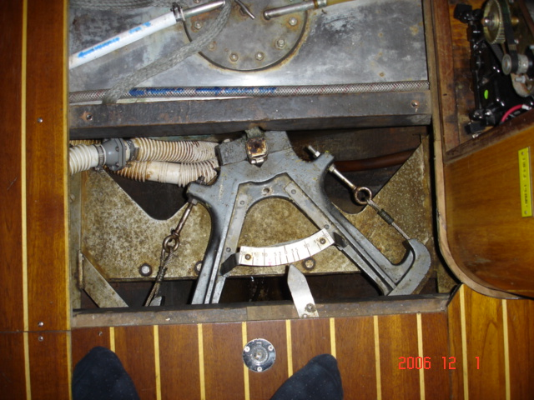
Figure 1 – Trim Tab Quadrant – Trim Tab Stock Aluminum Bracing Plate.

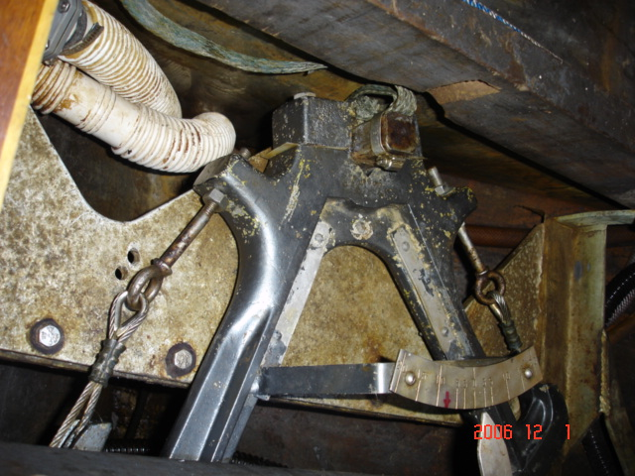
Figure 2 – Trim Tab Quadrant – Trim Tab Stock Aluminum Bracing Plate.

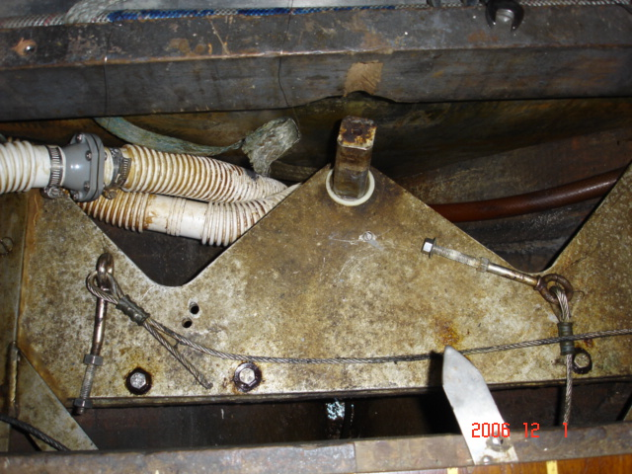
Figure 3 – Trim Tab Stock and Upper (white) Bushing and Aluminum Bracing Plate.

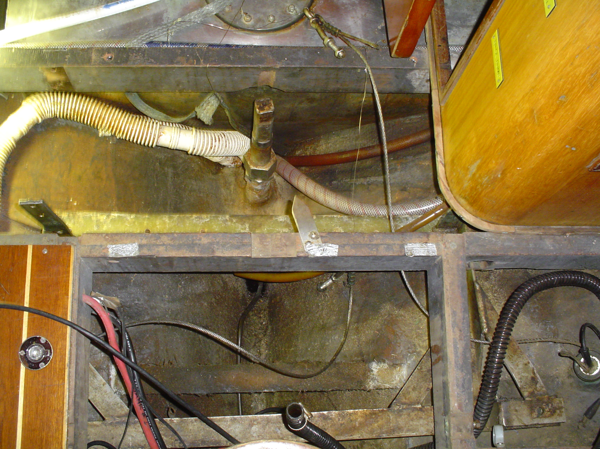
Figure 4 – Trim Tab Aluminum Bracing Plate and Battery Box Removed – Access to Trim Tab Tubing and Stuffing Box Packing Nut.

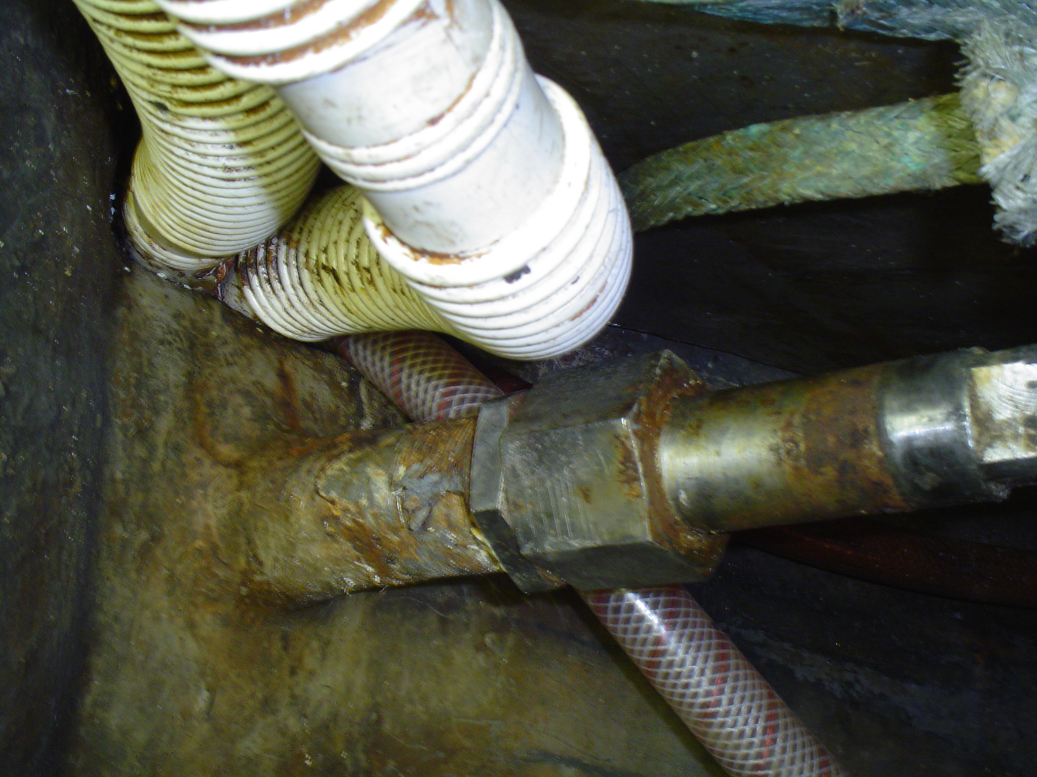
Figure 5 – Trim Tab Tubing and Stuffing Box Packing Nut (note cracked / missing metal from tubing directly below stuffing box packing nut assembly).

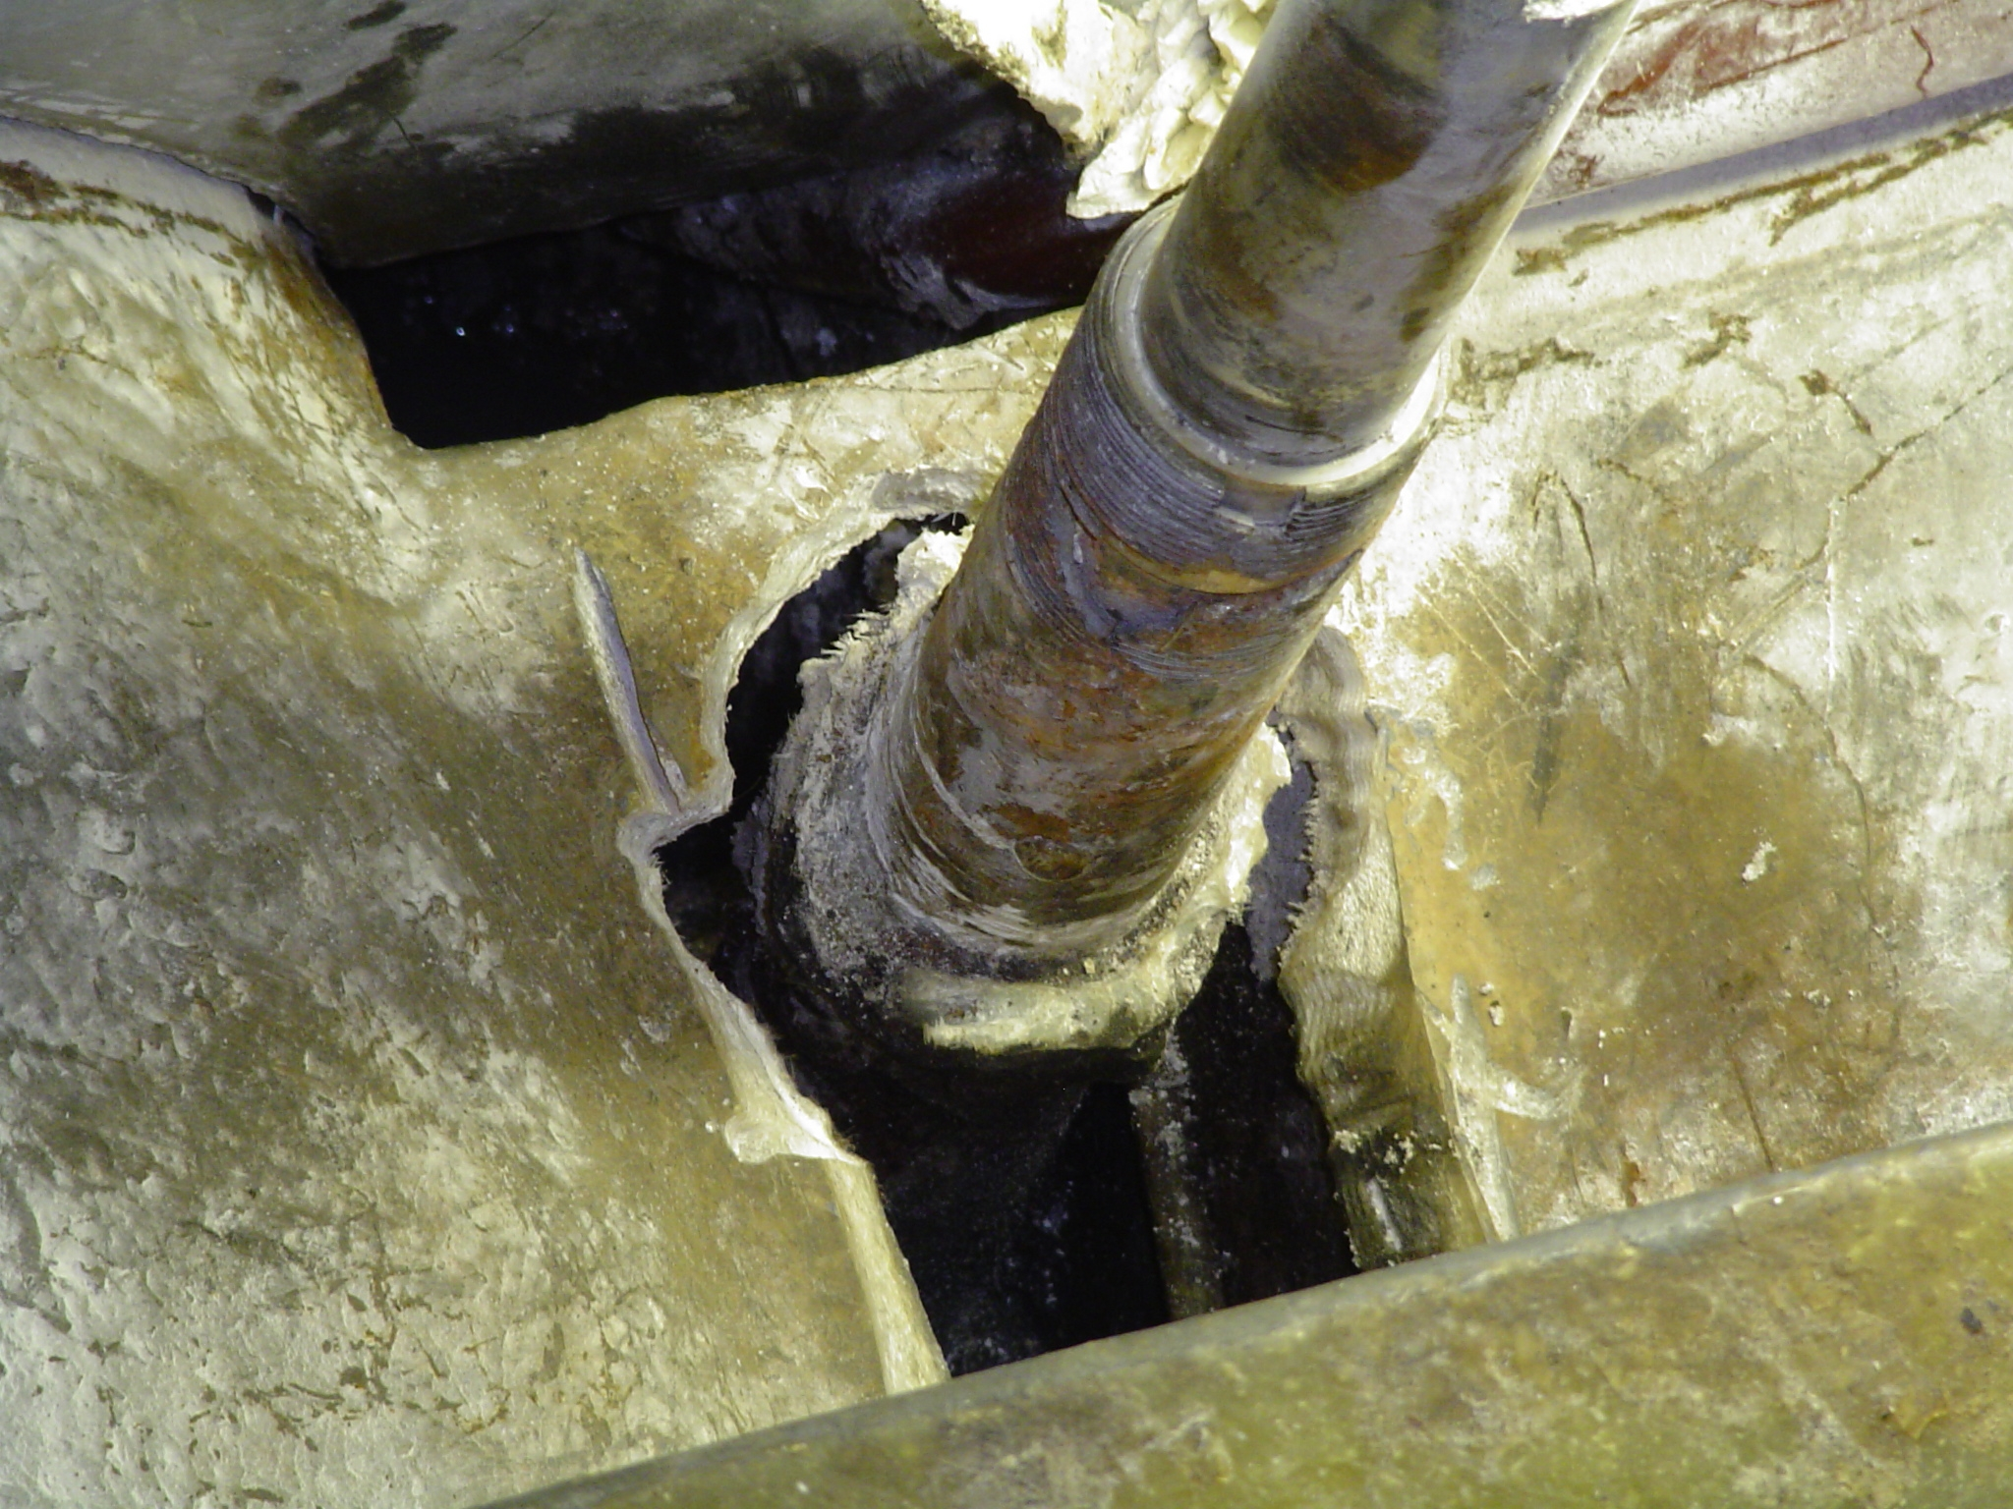
Figure 6 – Initial Attempt at Removal of Horizontal Fiberglass Brace Above Bilge at Trim Tab Tubing. (Not necessary and not recommended).
Also note cracked and missing metal at threaded portion of tubing.

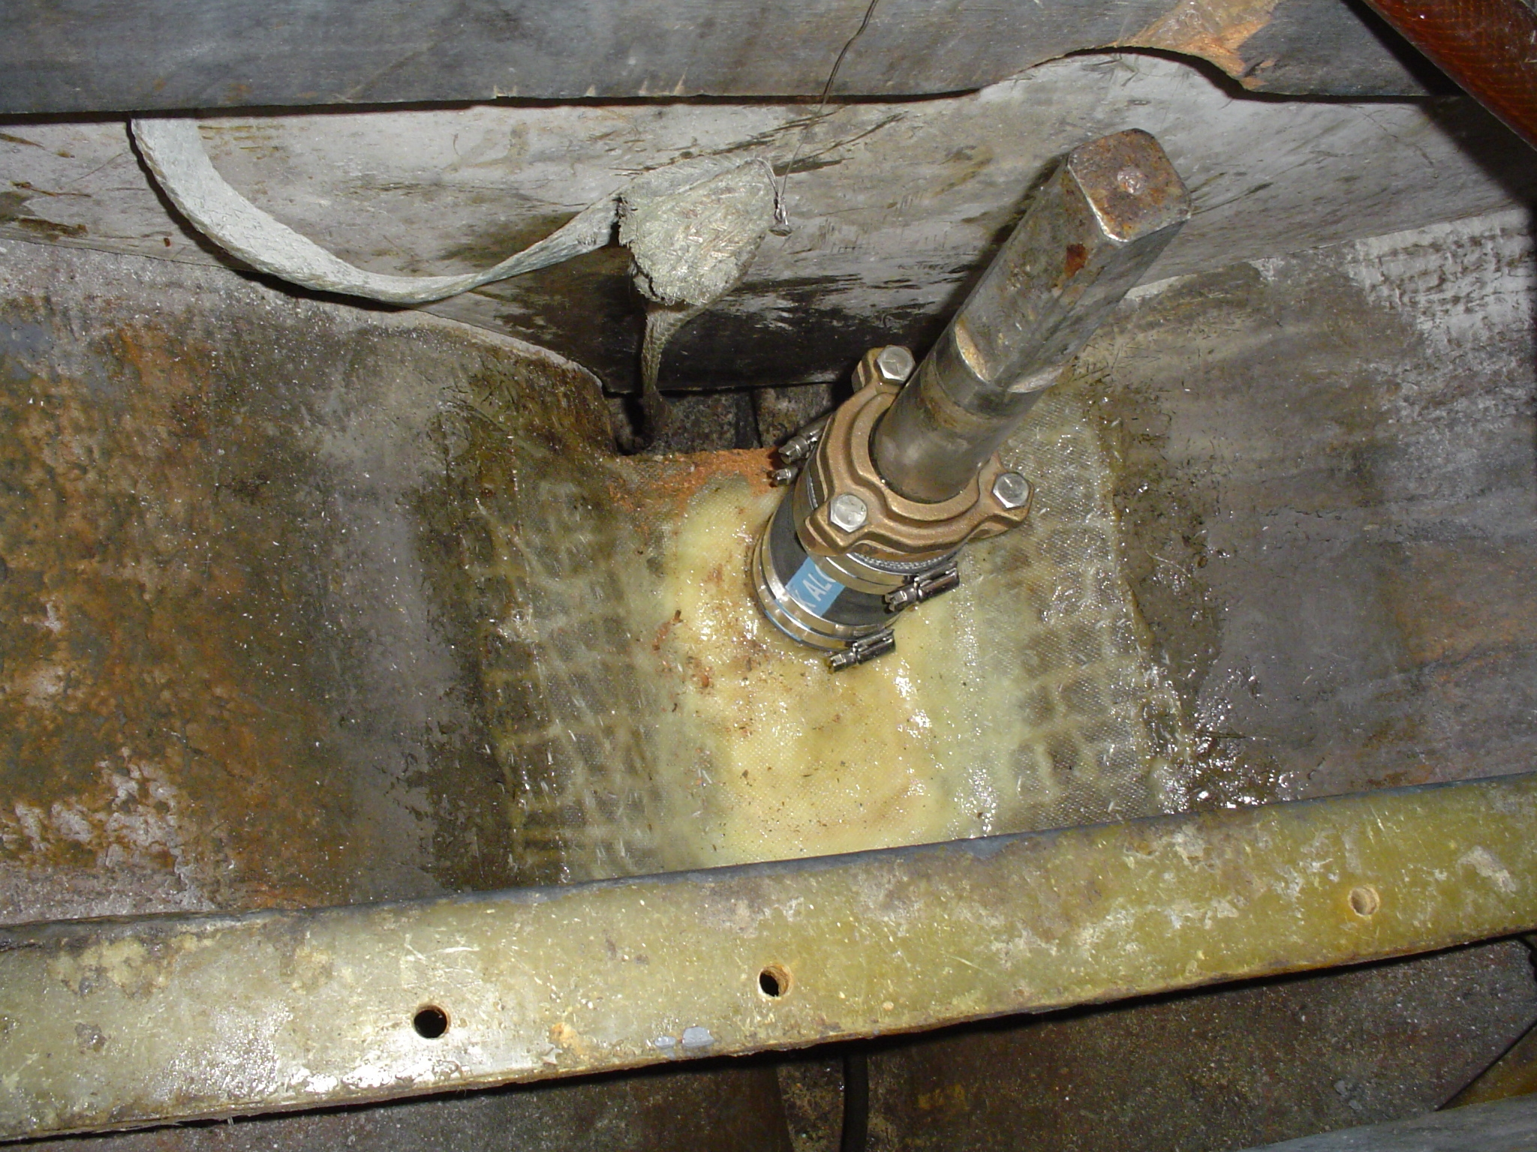
Figure 7 – New Bronze Edson Stuffing Box / Packing Nut Assembly with Rubber Hose and Stainless Steel Hose Clamps mounted over cut down existing trim
tab tubing.
(Note repair to existing fiberglass horizontal brace above bilge with new fiberglass cloth and West Epoxy - see figure 6 above. Repair replicates
the original horizontal brace which bridges across the existing bilge to maintain fore and aft continuity of the existing bilge.)

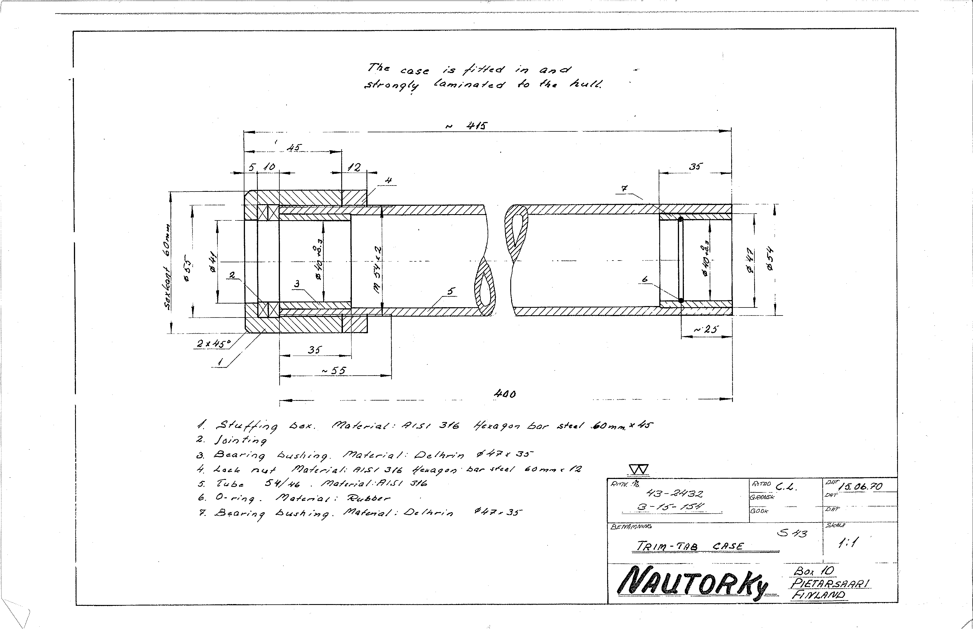
Figure 8 – Nautor engineering cross-sectional drawing of trim tab tube and stuffing box packing nut assembly (courtesy of Lars Strom and Nautor).

